**Code:**

* **index.html**

<!DOCTYPE html>

<html lang="en">

<head>

<meta charset="UTF-8">

<meta http-equiv="X-UA-Compatible" content="IE=edge">

<meta name="viewport" content="width=device-width, initial-scale=1.0">

<link rel="stylesheet" href="style.css">

<script src="https://ajax.googleapis.com/ajax/libs/jquery/3.6.3/jquery.min.js"></script>

<title>Form</title>

</head>

<body>

<div class="form">

<h1>Registration Form</h1>

<label for="name">Name:</label>

<input id="name" type="text">

<label for="username">username:</label>

<input id="username" type="text">

<label for="email">Email:</label>

<input id="email" type="email">

<label for="password">Password:</label>

<input id="password" type="password">

<button id="button" class="button">Register</button>

<script src="index.js"></script>

</div>

</body>

</html>

* **style.css**

.form{

display: flex;

flex-direction: column;

height: 100vh;

gap: 20px;

justify-content: center;

align-items:center ;

}

.form label{

font-size: 30px;

}

input{

width: 400px;

height: 30px;

padding-left: 10px;

}

.button{

width: 100px;

height: 30px;

background-color: red;

color: white;

border: 2px solid transparent;

cursor: pointer;

}

.button:hover{

background-color: green;

border: 2px solid black;

}

* **index,js**

const button = document.getElementById('button');

let details=localStorage.getItem("details") ||[];

const submitHandler = () => {

const name = document.getElementById('name').value;

const username = document.getElementById('username').value;

const email = document.getElementById('email').value;

const password = document.getElementById('password').value;

let xhr = new XMLHttpRequest();

xhr.open("POST", "https://jsonplaceholder.typicode.com/users");

xhr.setRequestHeader("Content-type", "application/json");

xhr.send(JSON.stringify({

name: name,

username: username,

email:email,

password:password

}));

xhr.onload = function() {

details.push(JSON.parse(xhr.response));

localStorage.setItem("details", JSON.stringify(details));

window.location.href = "/secondPage.html";

};

}

button.addEventListener('click', submitHandler)

* **SecondPage.html**

<!DOCTYPE html>

<html>

<head>

<title>User Information</title>

<style>

body {

display: flex;

flex-direction: column;

justify-content: center;

align-items: center;

margin-top: 10%;

font-family: Arial, Helvetica, sans-serif;

}

li {

width: 400px;

font-size: larger;

padding-bottom: 5%;

padding-left: 10%;

border-bottom: 1px solid gray;

}

p {

height: 10px;

}

</style>

</head>

<body>

<h1>User Information</h1>

<ul id="users-list" style="height: 50px;"></ul>

<script>

let details = JSON.parse(localStorage.getItem("details")) || [];

let list = document.getElementById("users-list");

details.forEach(function (details) {

let item = document.createElement("li");

item.innerHTML = "<p><b>Name: </b>" + details.name + "</p>" +

"<p><b>Email: </b>" + details.email + "</p>" +

"<p><b>Username: </b>" + details.username + "</p>" +

"<p><b>Password: </b>" + details.password + "</p>"

list.appendChild(item);

});

</script>

</body>

</html>

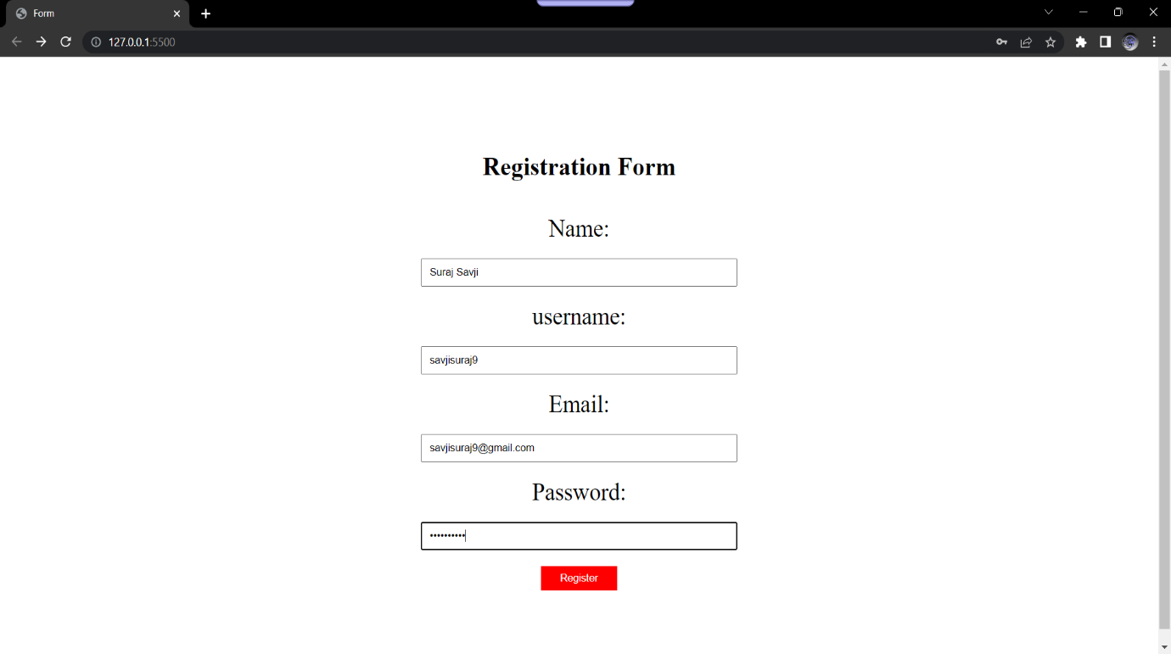**Output:**

